1 Motivation:

In order to make the receive board works will.

2 Method:

Set a test program that have a below function:

1. Receive an input signal from IO
2. When the signal comes, turn on a LED.

3 now the test module

Now we use the ILA to debug the file.

<https://www.youtube.com/watch?v=kTjeTOf6ACI>

Now we do not use the logic analyzer, we just use the traditional LED to show the result.

Next we should try the logic analyzer to do so.

fake project:

1 here is the simulation:

Following shows the simulation result.

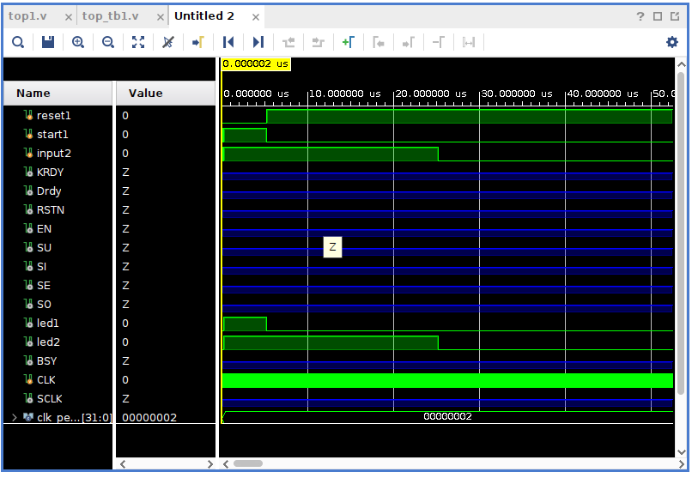

When the ‘led1’ turns on, it says the start1 signal start to input the signal into the input2 machine.

When the ‘led2’ turns on, it shows the input signal(input2) is high, and the testbench is sending the signal.